WEEK 2 – Provider-Agnostic LLM Client

Step-01: Download Ollama
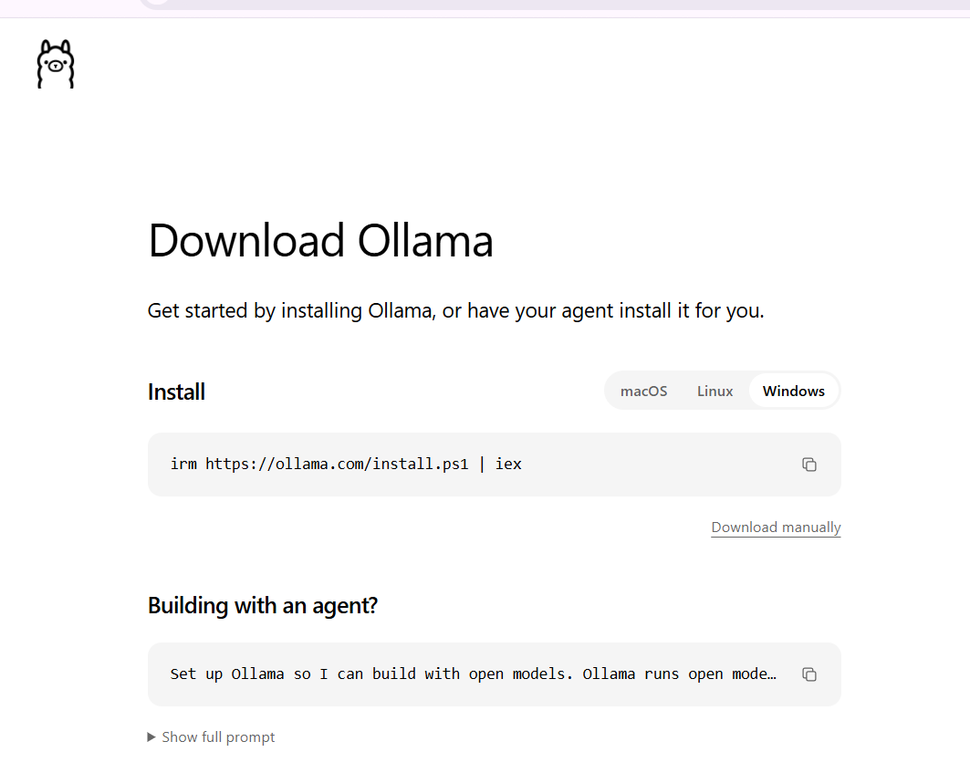

Step-02: Verify Ollama Installation
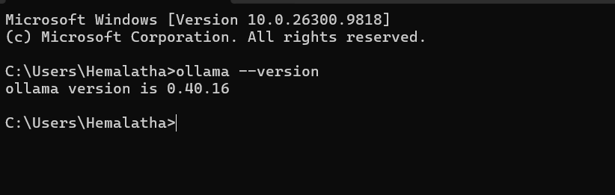

Step-04: Download Llama 3.2 Model
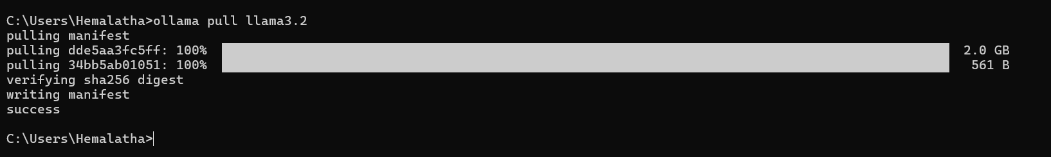

Step-05: Create Week-2 Project Files
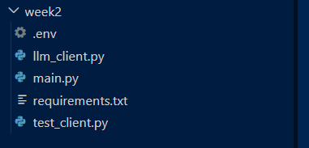

Step-06: Implement LLM Client
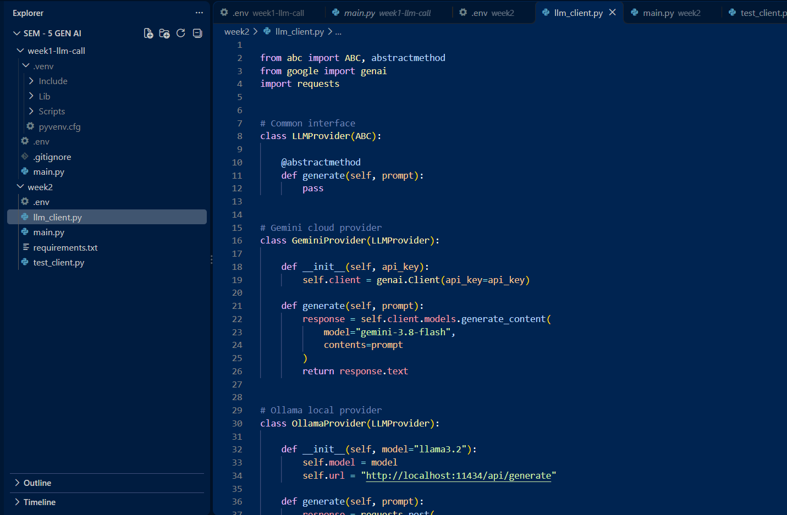

Step-07: Implement Main Program
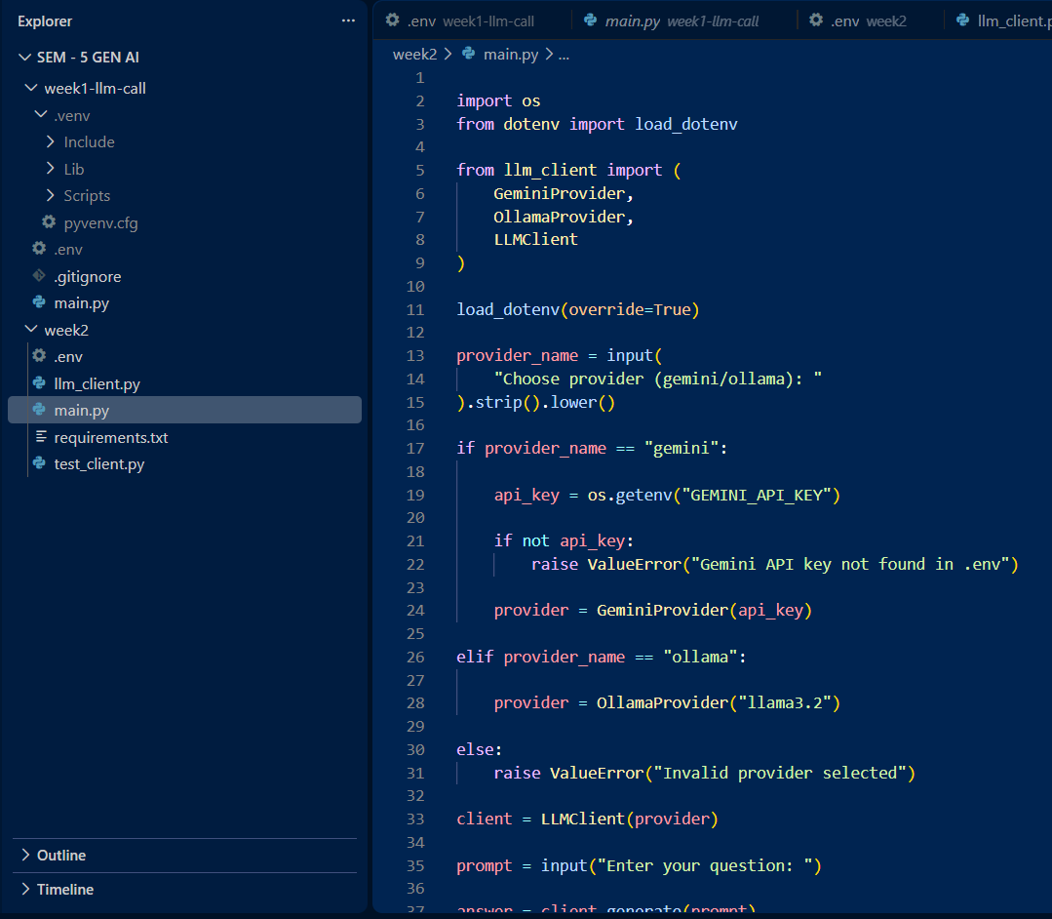

Step-08: Implement Unit Testing
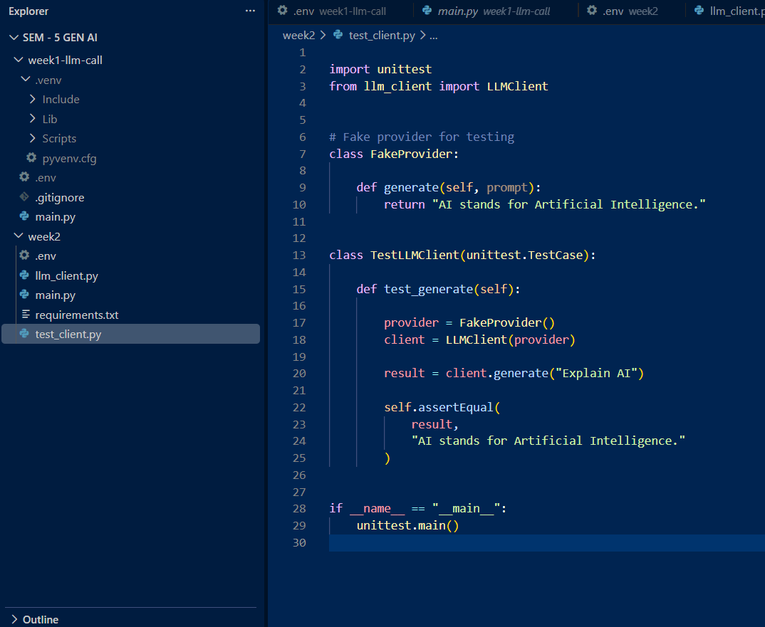
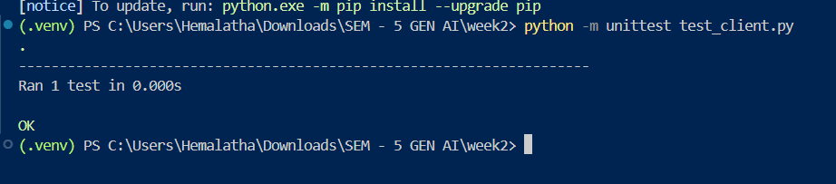

Step-09: Install Dependencies
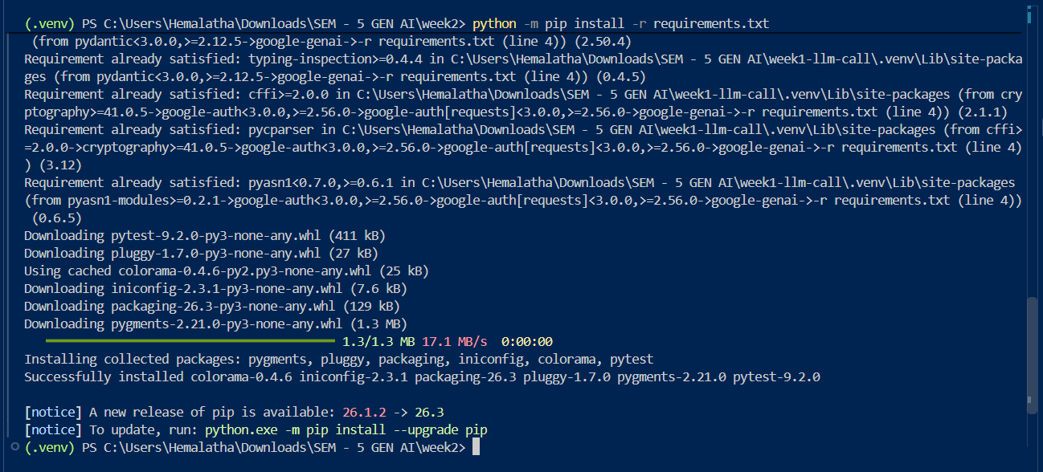

Step-10: Execute and Test the Application
USING OLLAMA:
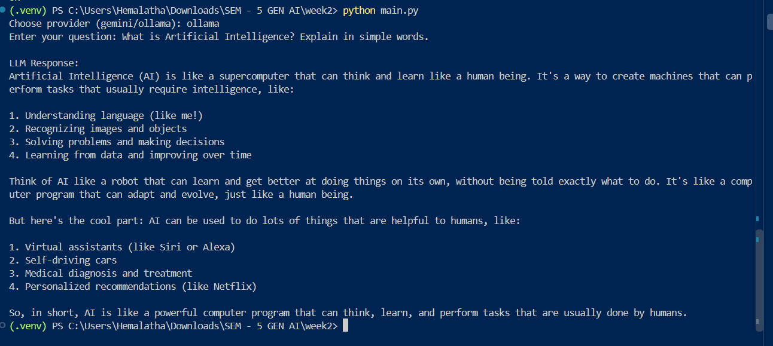
USING GEMINI:
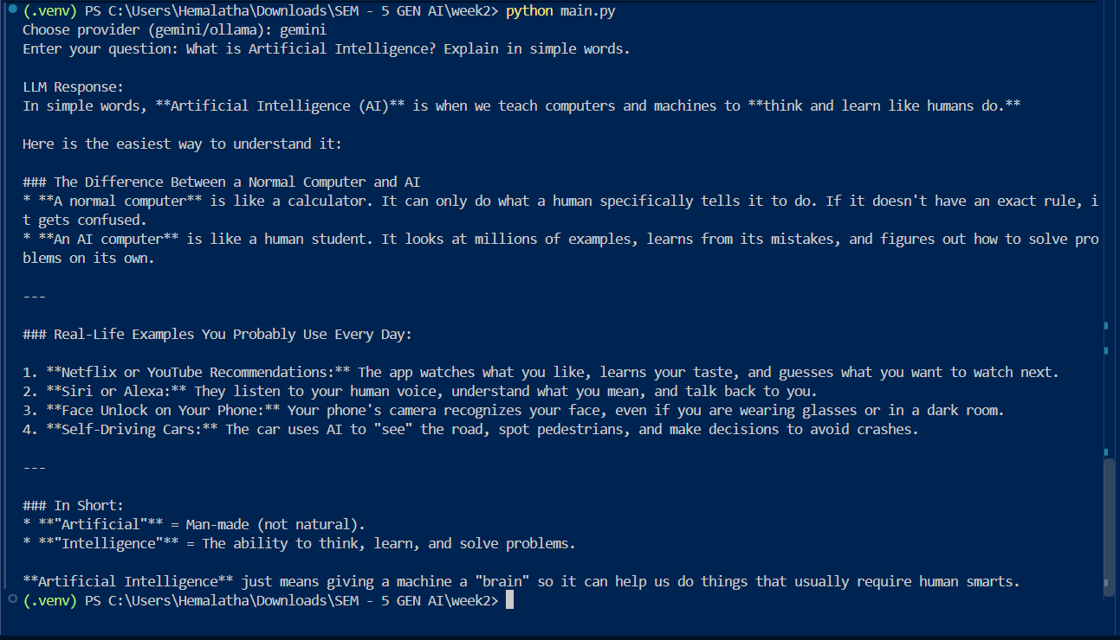

Step-11: Uploading Project to GitHub


